# Letters:

## Summary for itch.io page:

*I know I’m not the first patient the ‘Doctor’ has ‘saved’. But I’m going to make sure that you’re the last.*

Wake up chained to a chair in the middle of the room where the haunting footsteps of your captor echo and creak above you as you struggle against your confinements. Solve puzzles and keep careful watch—the Doctor can’t know that you’re trying to escape. As the clock ticks down, the promise of being “saved” by the draws ever near—but there has to be something, *anything*, that just might be enough to get you out…

Made by (**LIST OF NAMES HERE**) for TritonWare Fall 2024!

## Tutorial:

If you’re reading this, then you’re here to be ‘saved’. The Doctor has promised you salvation—don’t listen to him. There is nothing left here that’s worth saving. He’s monitoring your behavior, watching like you’re nothing but a rat in a cage.

Luckily for us, the Doctor is easily distracted. He gets caught up with his other ‘patients’.

In a few moments, you may notice that you can move freely in this room—we’ve been able to loosen the chain so you can access all of the walls. Turn your head [**Q & E**] to see them. Some of us in the past have gotten close to escape. But it was never enough. We’ve left behind everything you need to get out of here, but we had to hide them behind riddles and traps so the Doctor would think we’ve just gone mad. But even if we couldn’t ever do it in time, maybe you can. We’ve left you notes for each puzzle. It was the least we could do for you.

Keep in mind, the Doctor likes to watch. You’ll hear the creaking from upstairs when he comes back to check on you. The lights start to fizzle out when he’s around too. Get back in the chair and pretend like nothing’s wrong. Don’t look at him. Don’t say anything. Don’t answer any of his questions. Wait for him to leave.

**Do not let him catch you working on the puzzles.**

Your time’s running out.

If this is the last time you hear from me, then I’ve been ‘saved’ already. For all it’s worth, I hope you survive. For all of us.

# Puzzle Notes:

## Puzzle 1:

Color in the lines, and stay in your lane. The doctor doesn’t like patients who stray. Everyone walks alone.

## Puzzle 2:

Just watch what I do first. Take my hand, don’t let go, and step exactly where I step. Keep your eyes open, or you might miss it.

## Puzzle 3:

somewhere, somehow, he is watching me.

i can’t Breathe when the lights are off,

the drum in my Chest starts,

i feel the Butterflies swarm,

my Throat starts to close,

and my Mind cuts to black.

# Puzzle Design:

## Puzzle 1:

| X | X |  |  |  |  |
| --- | --- | --- | --- | --- | --- |
|  |  |  | X | X |  |
| X |  |  | X |  |  |
|  |  |  |  |  |  |
|  | X |  |  | X |  |
|  |  |  | X | X |  |

X

| X | X |  |  |  |  |
| --- | --- | --- | --- | --- | --- |
|  |  |  | X | X |  |
| X |  |  | X |  |  |
|  |  |  |  |  |  |
|  | X |  |  | X |  |
|  |  |  | X | X |  |

[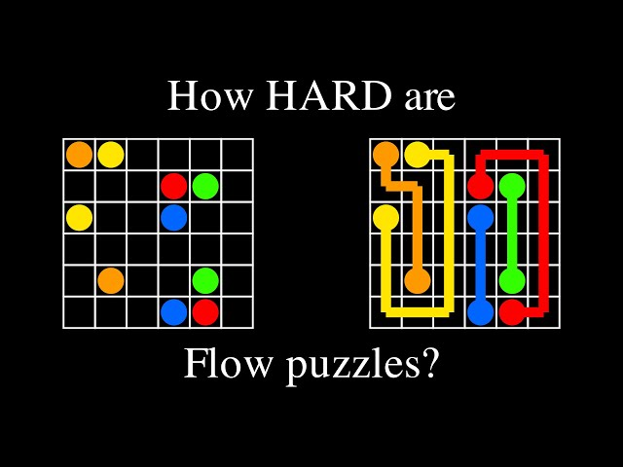](https://www.youtube.com/watch?app=desktop&v=_2A3j9hSqnY&ab_channel=probabilis)

## 

## Puzzle 2:

| X |  |
| --- | --- |
|  |  |

| X |  |
| --- | --- |
|  | X |

| X | X |
| --- | --- |
|  | X |

| X | XX |
| --- | --- |
|  | X |

| X | XX |
| --- | --- |
| X | X |

## Puzzle 3:

**Lungs**

**Heart**

**Stomach**

**Esophagus**

**Brain**

Decoys:

Liver

Kidneys

Intestine

Eyeball

Pancreas

# Interactable Objects Flavor Text:

* The radio is quiet.
* The desk is covered in a wet film. It clings to the pads of your fingers.
* There’s a thick layer of dust on these books.
* The drawer is jammed.
* You can’t force it open.
* It’s empty.
* It’s full of thumbtacks.
* It’s full of rat bones.
* You shouldn’t drink this.
* The wires are frayed—better not touch them.
* The rubber is peeling off.
* It looks like it hasn’t been cleaned in decades.
* This stool wobbles.
* This pen is missing an ink cartridge.

For the Wall with Door:

* The light is making a low humming sound.

If Doctor is Not Present:

* Someone could stick their hand through the bars.
* The door is locked.

If Interact with Door while Doctor is Present:

* See Kill Condition 3.)

# Doctor (Random Dialogue Lines):

* It’s almost time for your shots…
* Let’s have a heart to heart…what scalpel do you prefer?
* What’s your name? Can’t we still be friends?
* I hope you’re taking your medicine…
* Can you reach out your hand? I need to take your pulse…
* Aren’t you lonely in there, all by yourself?
* Don’t worry, I’ll save you…

# Kill Conditions:

1. If player is working on a puzzle after the Doctor is here (5 seconds of flashing lights or auditory cue), Doctor jumpscare.
2. If player time runs out, indicate via a dialogue line.
   1. “Oh, look. It’s your turn to be saved.” Doctor jumpscare
3. If player attempts to interact with the window while the Doctor is “checking in on you”, Doctor jumpscare